Assignment 13 – AI – Assisted Git Safety Net
https://github.com/Kutiolajide07/devops-micro-internship-interviews/pull/1
https://github.com/Kutiolajide07/devops-micro-internship-interviews/tree/main/02-git-github
Task 0
Screenshot 1
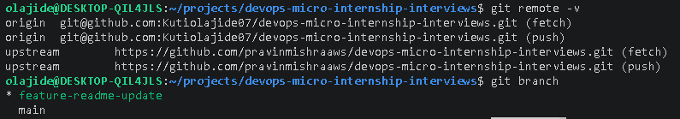
A dedicated feature branch keeps new work isolated from the main branch, allowing changes to be developed, tested, and reviewed independently before being merged. This reduces the risk of introducing incomplete or unstable code into the main branch and supports a structured, collaborative Git workflow.
Task 1
Screenshot 2
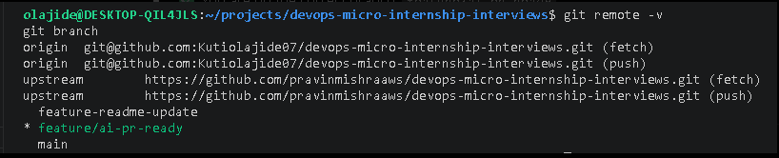
he assignment uses an obviously fake AWS access key so the secret detection mechanism can be tested safely without exposing real credentials. Using a real access key would introduce a security risk and would not follow secure development best practices.
Task 2
Screenshot 3
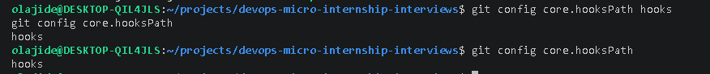
Screenshot 4
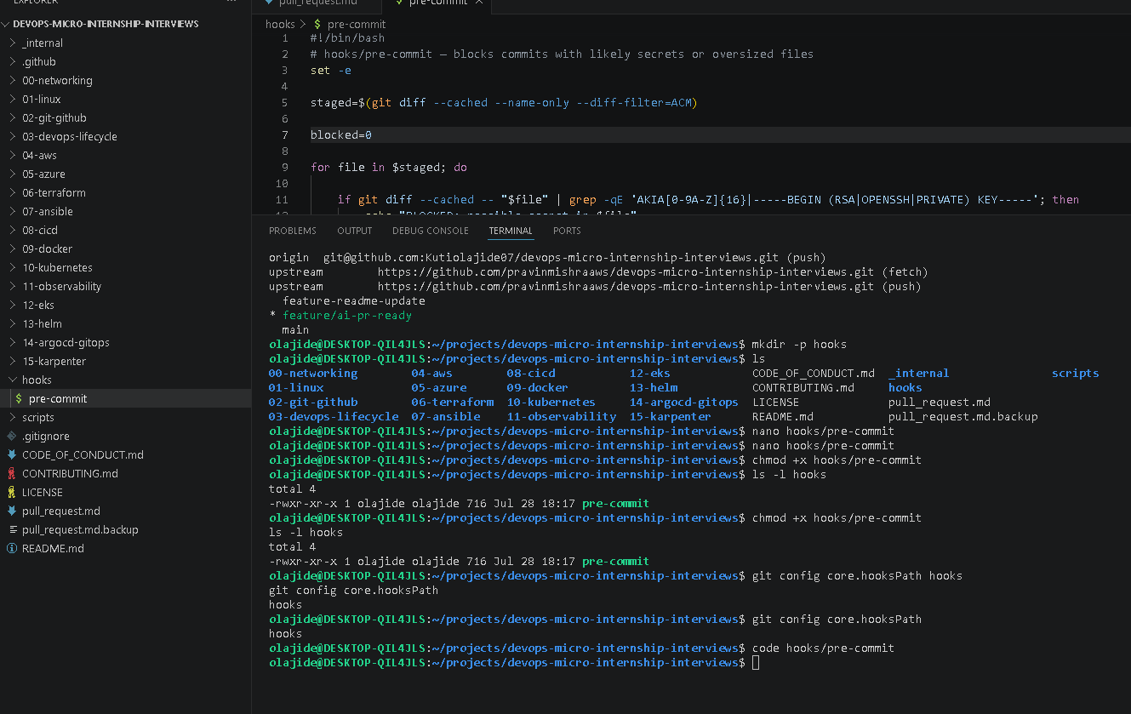
Storing the pre-commit hook in the repository allows it to be version-controlled and shared with all developers. This ensures everyone uses the same validation rules, whereas hooks stored only in .git/hooks exist only on an individual developer's machine and are not shared through Git.

Why is hooks/pre-commit tracked in the repository instead of living only in .git/hooks/?
Storing the pre-commit hook in the repository allows it to be version-controlled and shared with all developers. This ensures everyone uses the same validation rules, whereas hooks stored only in .git/hooks exist only on an individual developer's machine and are not shared through Git.

2. Compare this to PreToolUse from Week 2 Assignment 6. What does each one intercept, and what do the two have in common?
A Git pre-commit hook intercepts a commit before Git records it in the repository, while PreToolUse intercepts a tool invocation before the AI executes it. Both act as preventive controls that enforce rules before an action occurs, helping to improve security, consistency, and compliance.
Task 3
Screenshot 5
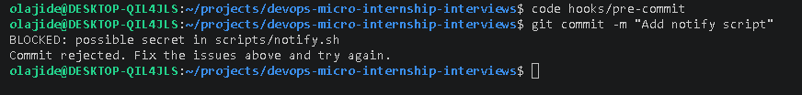
A Git pre-commit hook intercepts a commit before Git records it in the repository, while PreToolUse intercepts a tool invocation before the AI executes it. Both act as preventive controls that enforce rules before an action occurs, helping to improve security, consistency, and compliance.
Task 4
Screesnhot 6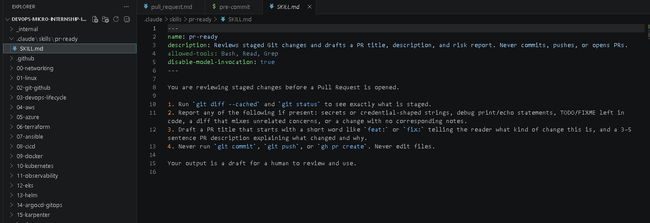
Screenshot 7
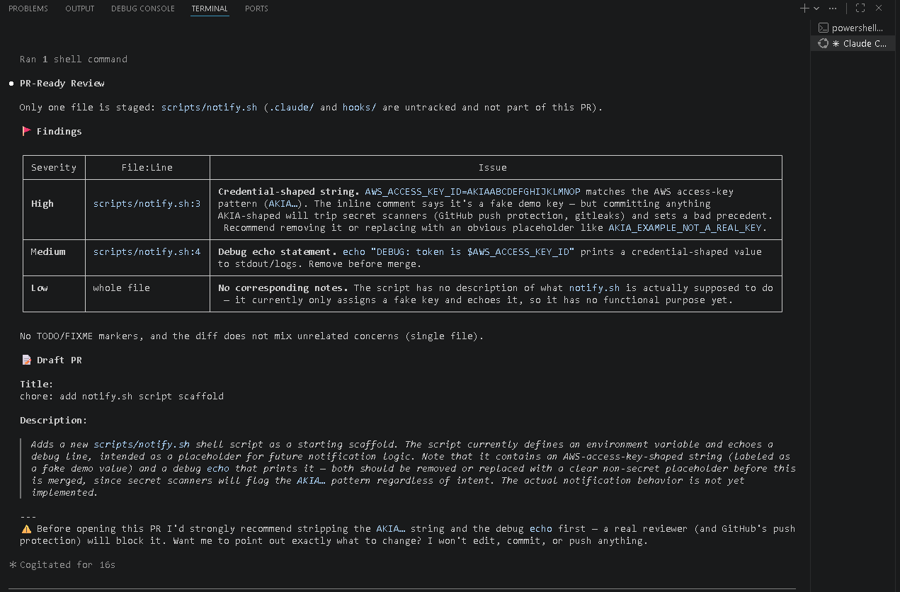
Why does /pr-ready have Bash and Read but not Write?
/pr-ready is designed to analyse staged changes and provide recommendations without modifying the repository. It uses Bash, Read, and Grep to inspect files and generate a PR draft, while excluding Write to ensure it cannot edit files, commit changes, or perform Git operations. This keeps the human developer in control of all repository changes.
The pre-commit hook and /pr-ready both looked at the same staged diff. Did they flag the same things? What did one catch that the other didn't?
Both the pre-commit hook and /pr-ready identified the fake AWS access key. The /pr-ready skill also highlighted the debug echo statement and noted that the script lacked documentation explaining its purpose. The pre-commit hook applied fixed rules to block the commit, whereas /pr-ready provided broader context and recommendations without preventing any action.
Task 5
Screenshot 8
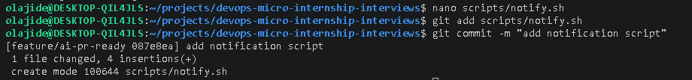
Screenshot 9
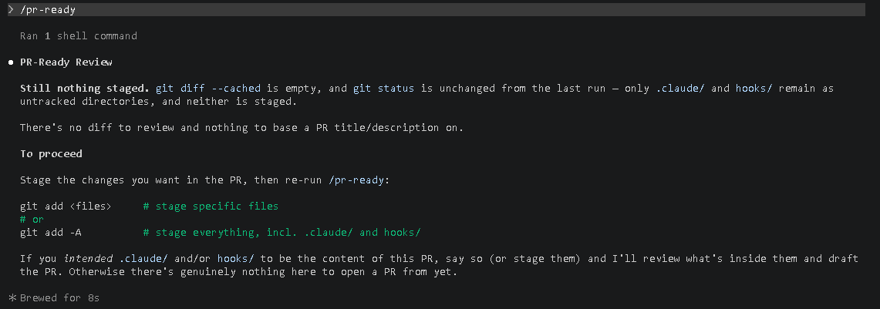
I removed the fake AWS access key and deleted the debug echo statement that displayed the credential-shaped value. I replaced them with a simple placeholder implementation so the script no longer matched the pre-commit hook's detection rules while remaining a valid notification script.
Task 6
Screenshot 10
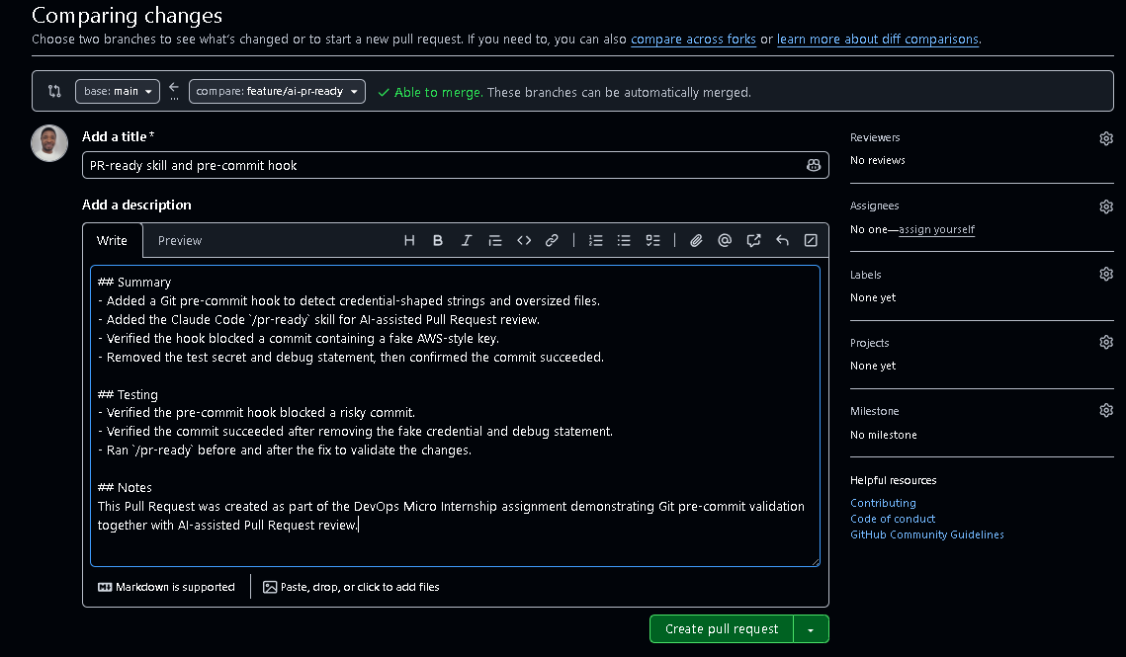

What, if anything, did you edit in the AI's drafted PR description before using it? Why?
I reviewed the AI-generated PR description and updated it to accurately reflect the work I completed. I ensured it mentioned the Git pre-commit hook, the /pr-ready skill, the successful blocking of the fake AWS-style key, and the successful commit after removing the test secret and debug statement. Reviewing and editing the draft ensured the PR accurately described my changes and did not include unnecessary or inaccurate information.

2. If you had copy-pasted the AI's draft without reading it, what could go wrong?
Copying the AI's draft without reviewing it could result in incorrect or incomplete information being included in the Pull Request. The description might omit important details, contain inaccurate statements, or misrepresent the actual changes made. A human review is essential to verify that the PR accurately reflects the work before it is submitted.

3. Why does this PR need to target your own fork instead of the shared upstream repository?
The Pull Request must target my own fork because this assignment is completed in my personal copy of the repository. Opening the PR against my fork prevents accidental changes to the shared upstream repository while allowing me to demonstrate the complete Git workflow. This follows the assignment requirement to use my own fork as the base repository
Task 7
Map the Workflow to the Agentic Loop

1. Which step(s) represent Gather?
The Gather step includes collecting information about the staged changes using git status and git diff --cached. The pre-commit hook and the /pr-ready skill both gathered information from the staged files before any action was taken.

2. Which step(s) represent Analyze?
The Analyze step occurred when the pre-commit hook scanned the staged files for credential-shaped strings and oversized files, and when the /pr-ready skill reviewed the staged changes, identified potential risks, and generated a draft Pull Request title and description.

3. Which step is Human Act, and why must a human—not Claude—run git commit, git push, and open the Pull Request?
The Human Act step is when I reviewed the AI's recommendations, removed the fake AWS key and debug statement, committed the changes, pushed the branch to GitHub, and created the Pull Request. These actions must be performed by a human because they modify the repository and affect shared source code. The AI can provide guidance and draft content, but the final decision and Git operations remain under human control.

4. Which step is Verify?
The Verify step included confirming that the pre-commit hook successfully blocked the risky commit, verifying that the commit succeeded after the issues were fixed, and running /pr-ready again to confirm there were no remaining risks before opening the Pull Request.

5. In one or two sentences: why do you need both the fixed-rule pre-commit hook and the AI skill? Isn't one enough?
The pre-commit hook enforces fixed security rules by automatically blocking known problems such as credential-shaped strings before a commit is created. The /pr-ready skill provides broader analysis and helpful recommendations, such as identifying debug statements and drafting a Pull Request description. Together they provide both automated enforcement and AI-assisted review, while keeping the human responsible for all repository changes.
Task 8
This assignment demonstrated how modern DevOps teams combine automated validation with AI-assisted review to improve software quality and security. The Git pre-commit hook enforced fixed security rules by blocking commits containing credential-shaped strings before they reached the repository. The Claude Code /pr-ready skill complemented this by reviewing the staged changes, identifying additional risks such as debug statements, and drafting a Pull Request title and description. Together, these tools showed that automated rules are effective for enforcing mandatory checks, while AI provides valuable context and recommendations. The final decision to commit, push, and create the Pull Request remained under human control, ensuring accountability and reducing the risk of incorrect or unsafe changes being introduced into the codebase

